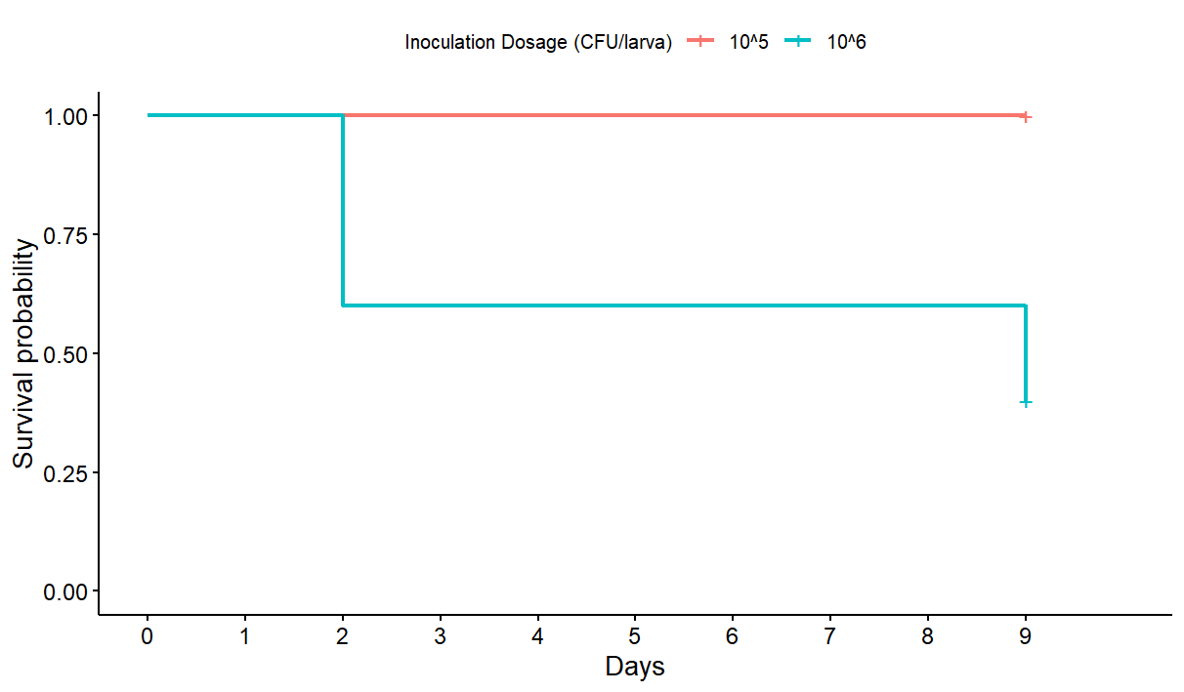

**FIG 2** Survival plot of the pathogenicity assay comparing two different inoculation doses. *G. mellonalla* larvae were infected with either 105 CFU/larva or 106 CFU/larva of *C. albicans* SC5314 (n = 10). Treatment groups were monitored for survival over 10 days.

**FIG 1** Survival plot of the antifungal and AmB-synergy efficacy assay of LF, LFG, LCL and LNL in *G. mellonella*. Larvae were infected with an inoculum of 105 CFU/larva of *C. albicans* SC5314. Treatment of AmB (124µg/mL), LF (1024µg/mL), LFG (4.16µg/mL), LCL (0.96µg/mL), LNL (0.72µg/mL), or a combination of a peptide and AmB, was administered (n = 10). Blank 10mM Tris Buffer was administered as a negative control (n = 10). Treatment group of were monitored for survival over 10 days.

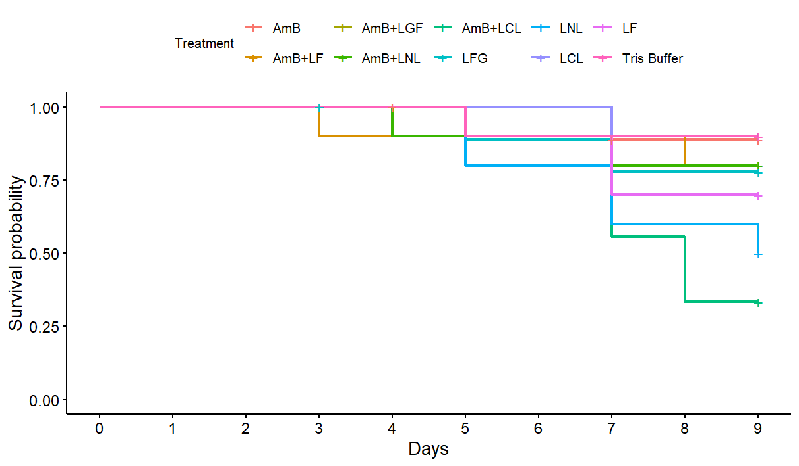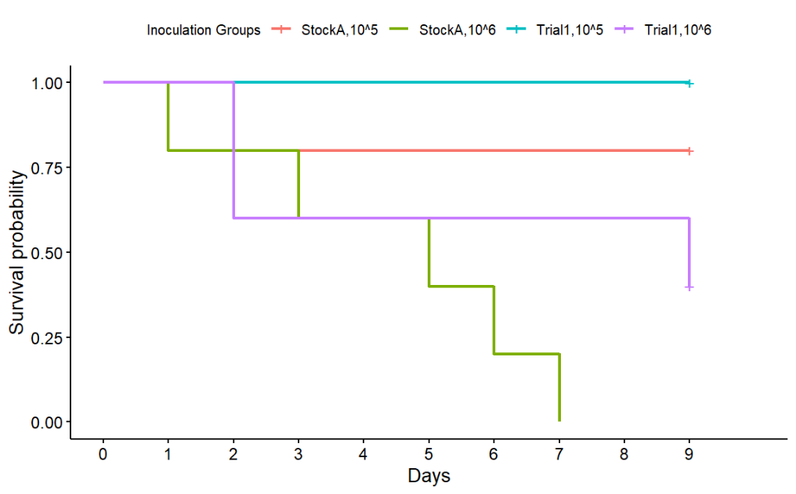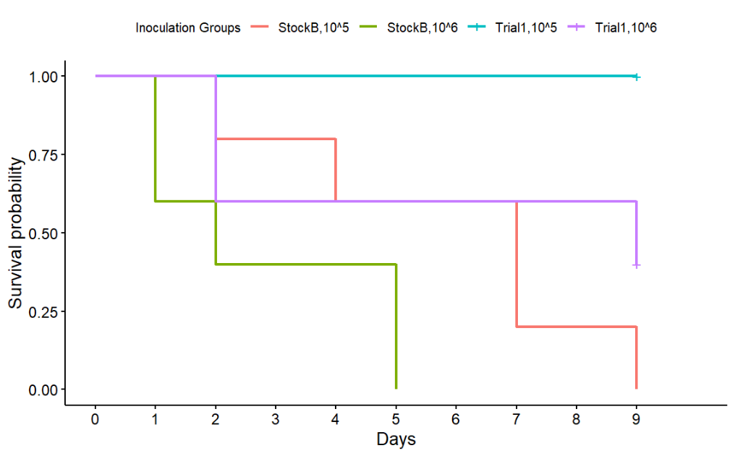

**FIG 4** Survival plots comparing the results of *Pathogeneticty assay 1* (Trial1) with the results of *Pathogenicity assay 2*, separated by glycerol stock. Comparisons for both 105 CFU/larva and 106 CFU/larva doses of *C. albicans* SC5314 are displayed. Plot **a)** compares Trial1 (n = 10) against StockA (n = 5), and **b)** compares Trial1 (n = 10) against StockB (n = 5).

**a)**

**b)**

**FIG 3** Survival plot of the pathogenicity assay comparing two different glycerol stocks of *C. albicans* SC5314. *G. mellonalla* larvae were infected with either 105 CFU/larva or 106 CFU/larva of *C. albicans* SC5314 cultures prepared from one of two glycerol stocks, StockA or StockB (n = 5). PBS was used as a negative control (n = 5). Treatment groups were monitored for survival over 10 days.

